Sidecar containers – Probes – KubectlDebug :

1.Sidecar containers

Init containers

1. We can have multiple init containers.
2. This will start and complete before app container
3. These are executed sequentially.

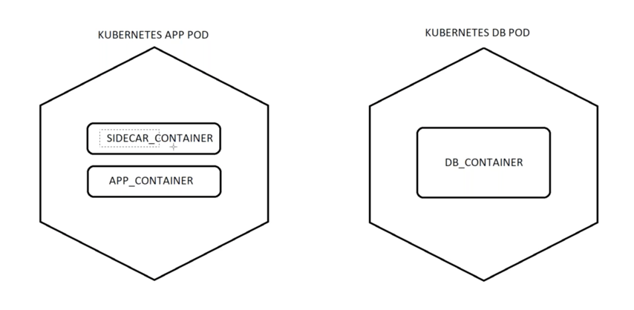

Here we have two pods, One pods contains the app_container and another pod contains the db_container. If we have a dependency like app_container should be up only after the db_container is up. At that time, there should be something(sidecar container’s – init container) to check whether db_container is up or not. If db_container is up, it should proceed further to make app_container up.

initContainer.yaml:

apiVersion: apps/v1

kind: Deployment

metadata:

labels:

app: init-testing

name: init-testing

spec:

replicas: 1

selector:

matchLabels:

app: init-testing

template:

metadata:

labels:

app: init-testing

spec:

initContainers:

- name: init-myservice1

image: busybox:1.28

command: ['sh', '-c', 'sleep 30']

- name: init-myservice2

image: busybox:1.28

command: ['sh', '-c', "until nslookup myservice.default.svc.cluster.local; do echo waiting for myservice; sleep 2; done"]

- name: fetch

image: mwendler/wget

command: ["wget","--no-check-certificate","https://sreek8s.s3.amazonaws.com/Sample-SQL-File-1000rows.sql","-O","/docker-entrypoint-initdb.d/dump.sql"]

volumeMounts:

- mountPath: /docker-entrypoint-initdb.d

name: dump

containers:

- name: mysql

image: mysql

env:

- name: MYSQL_ROOT_PASSWORD

value: "India123456"

volumeMounts:

- mountPath: /docker-entrypoint-initdb.d

name: dump

volumes:

- emptyDir: {}

name: dump

---

apiVersion: apps/v1

kind: Deployment

metadata:

labels:

app: adminer

name: adminer

spec:

replicas: 1

selector:

matchLabels:

app: adminer

template:

metadata:

labels:

app: adminer

spec:

containers:

- image: adminer

name: adminer

ports:

- containerPort: 8080

---

apiVersion: v1

kind: Service

metadata:

labels:

app: init-testing

name: init-testing

spec:

ports:

- port: 3306

protocol: TCP

targetPort: 3306

selector:

app: init-testing

---

apiVersion: v1

kind: Service

metadata:

creationTimestamp: null

labels:

app: adminer

name: adminer

spec:

ports:

- port: 8080

protocol: TCP

targetPort: 8080

nodePort: 31234

selector:

app: adminer

type: NodePort

In the above code we have two deployments and two services. One service(init-testing) is to expose init-testing deployment. Another service(adminer) is to expose adminer deployment on NodePort.

Create cluster and validate it and then run the below file like below:

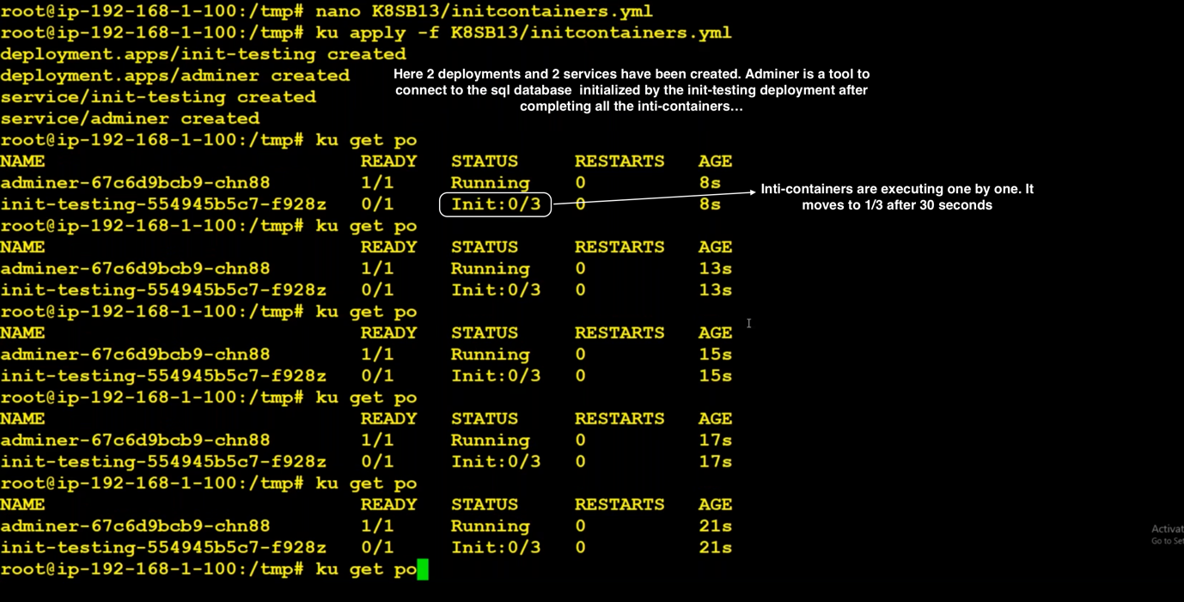

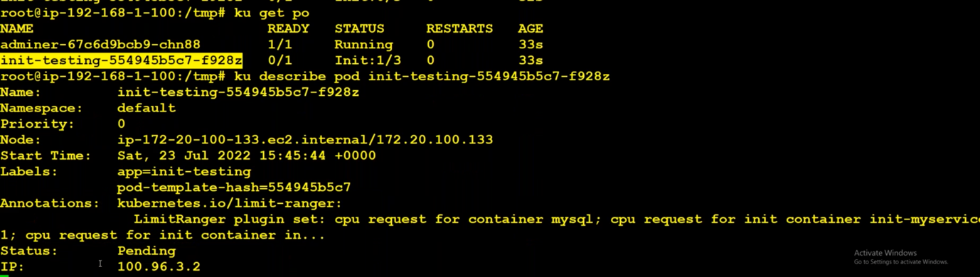

Now the first init-container gets completed. It will not move to second init-container because we have not created any service with myservice name.

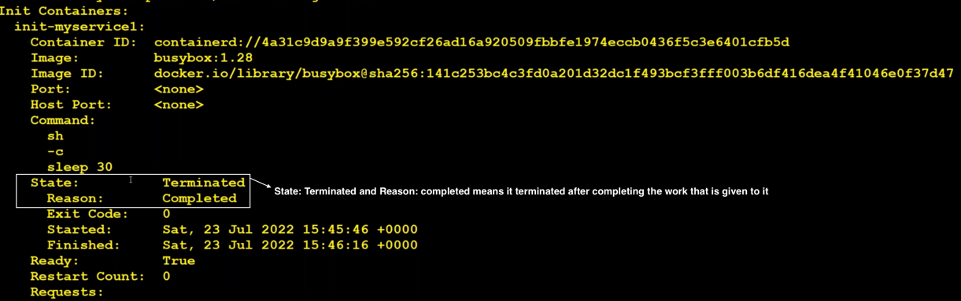

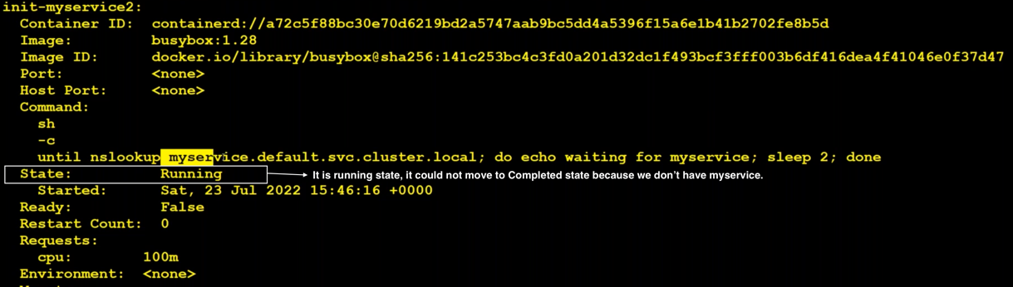

To move further we have to create a service. To create a service, we need a deployment.

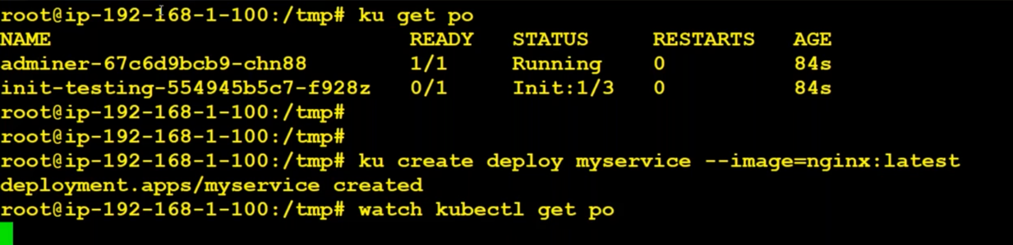

After creating deployment, we need to expose that deployment using a service.

Immediately after exposing the service, init-testing gets completed. It moves to 2/3 and 3/3 and initializes the pod.

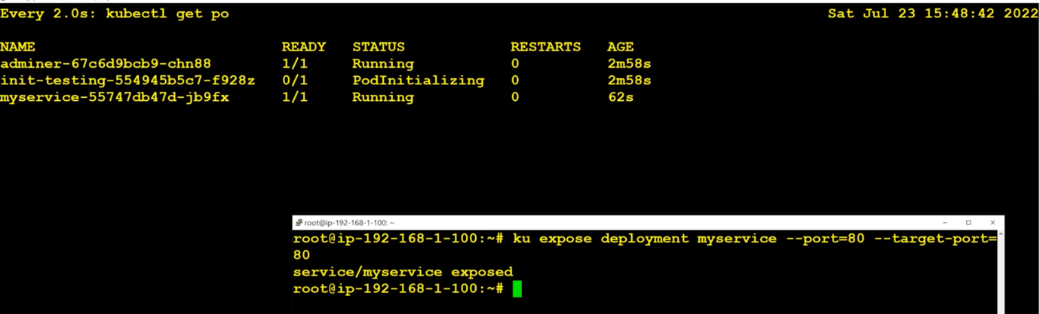

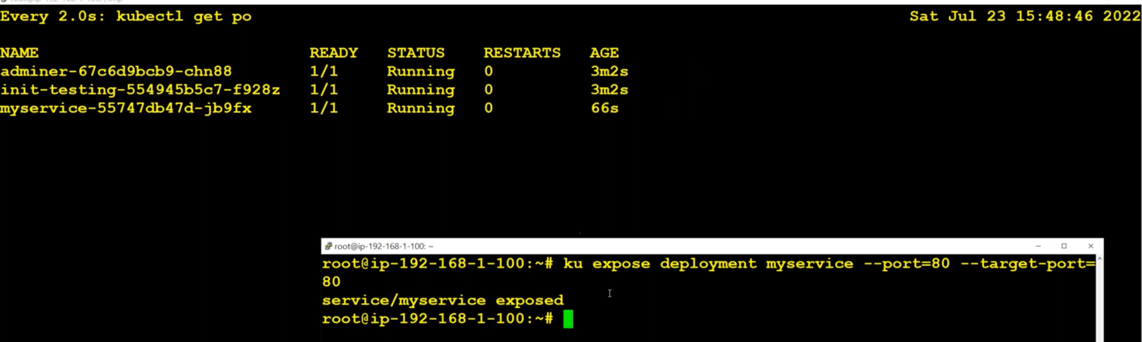

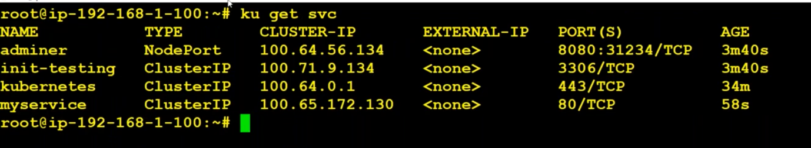

Modify in-bound rules in security groups of any one of the nodes and allow ‘All Traffice’.

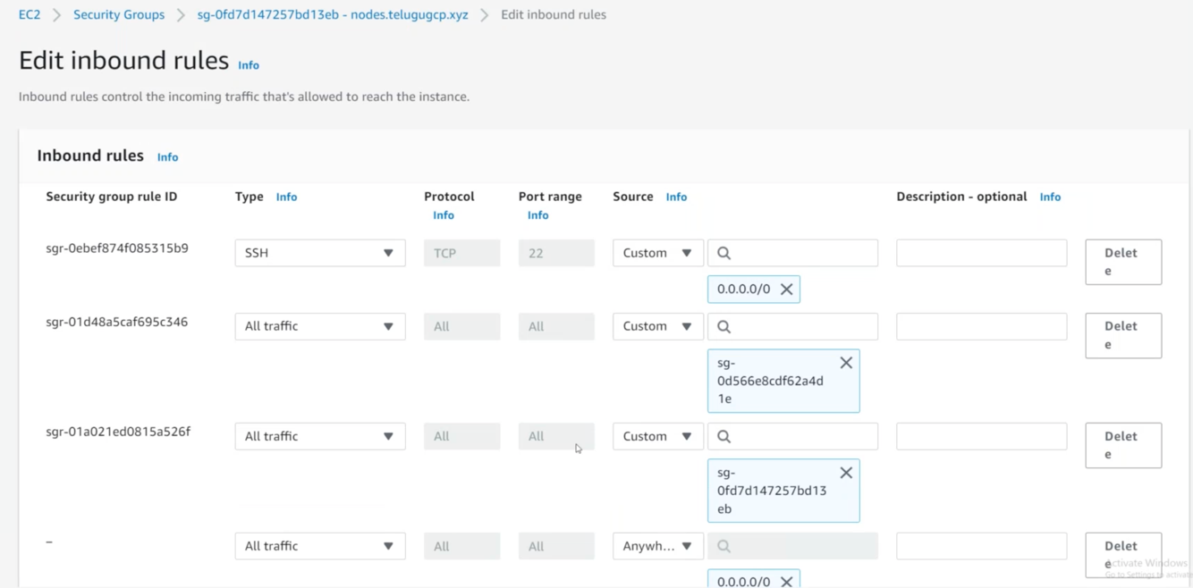

Try accessing adminer:

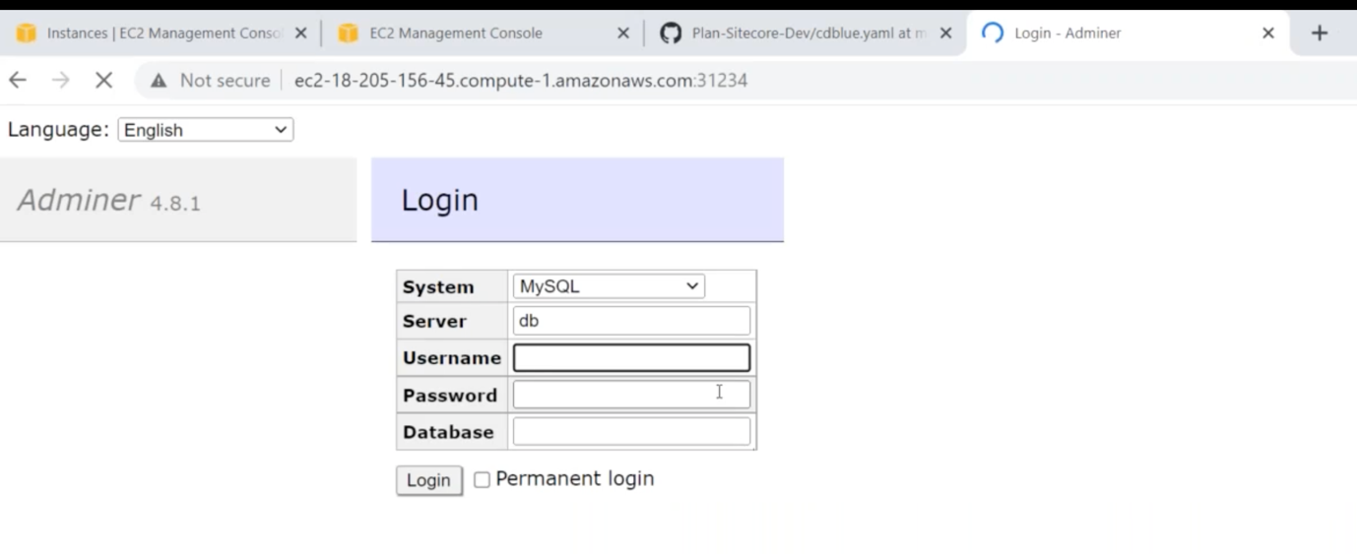

Server means the service name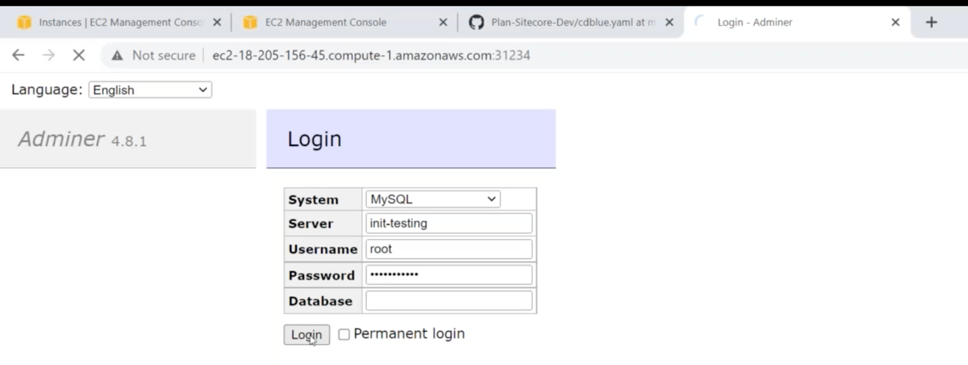

Check whether the database contains the details that inti-container3 has loaded.

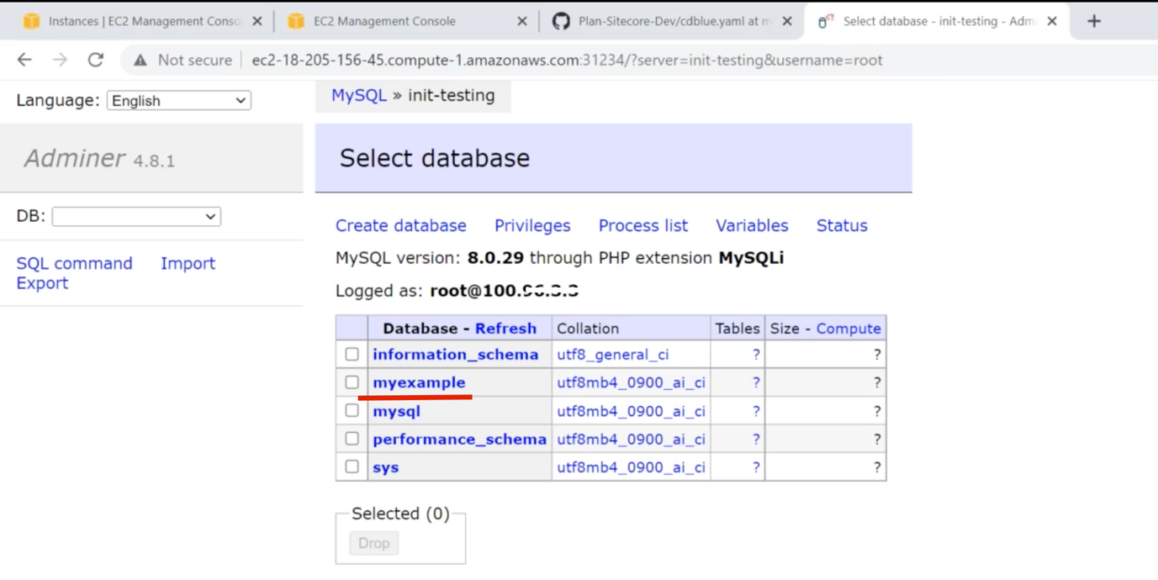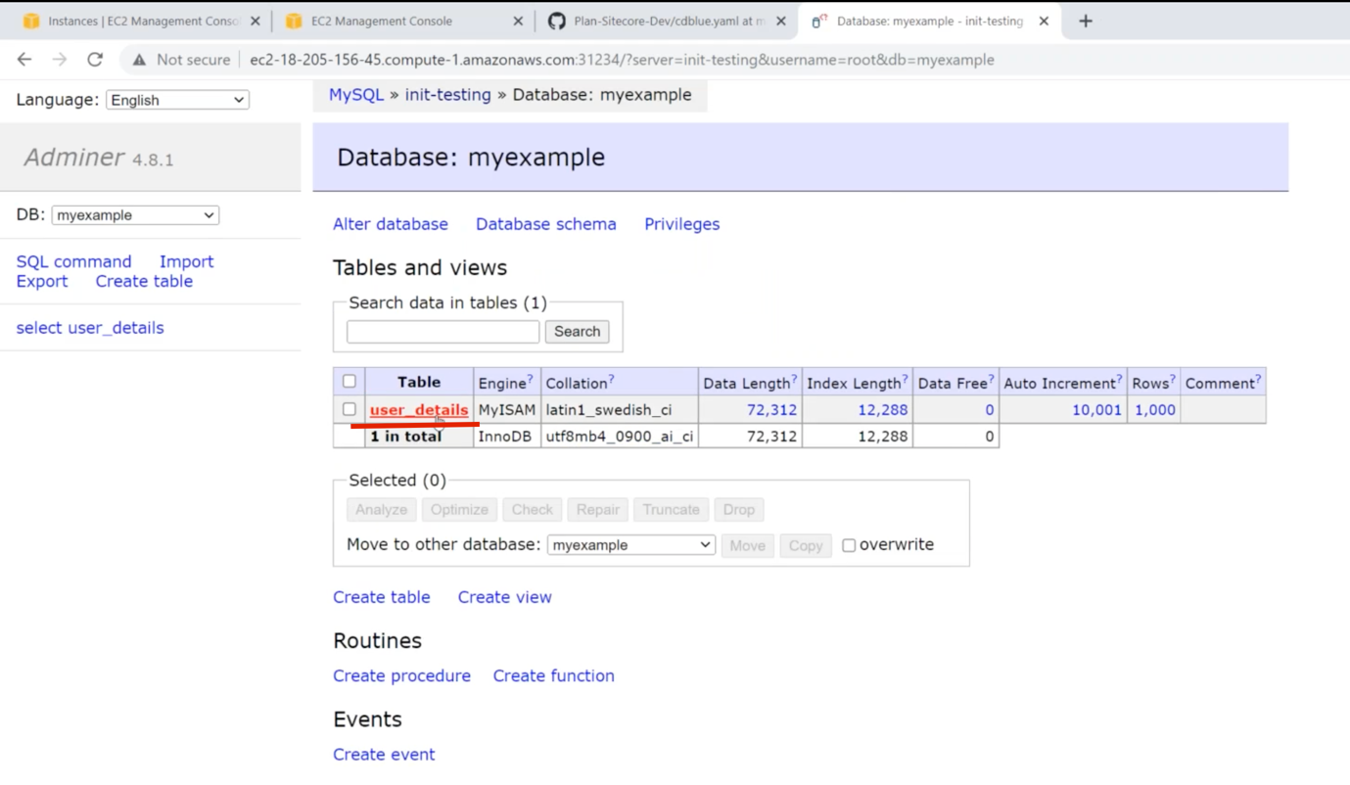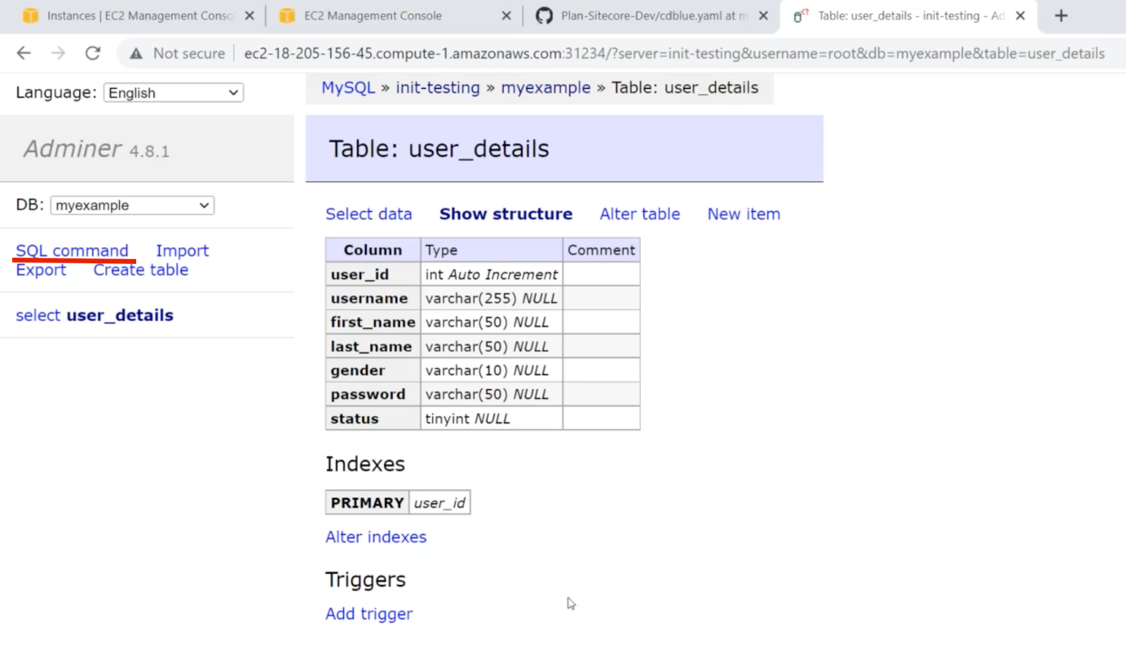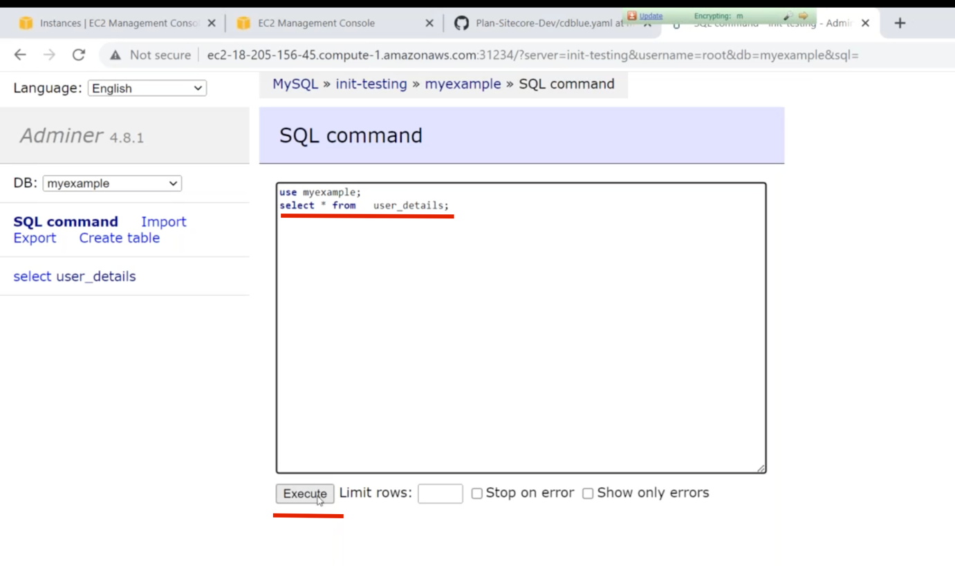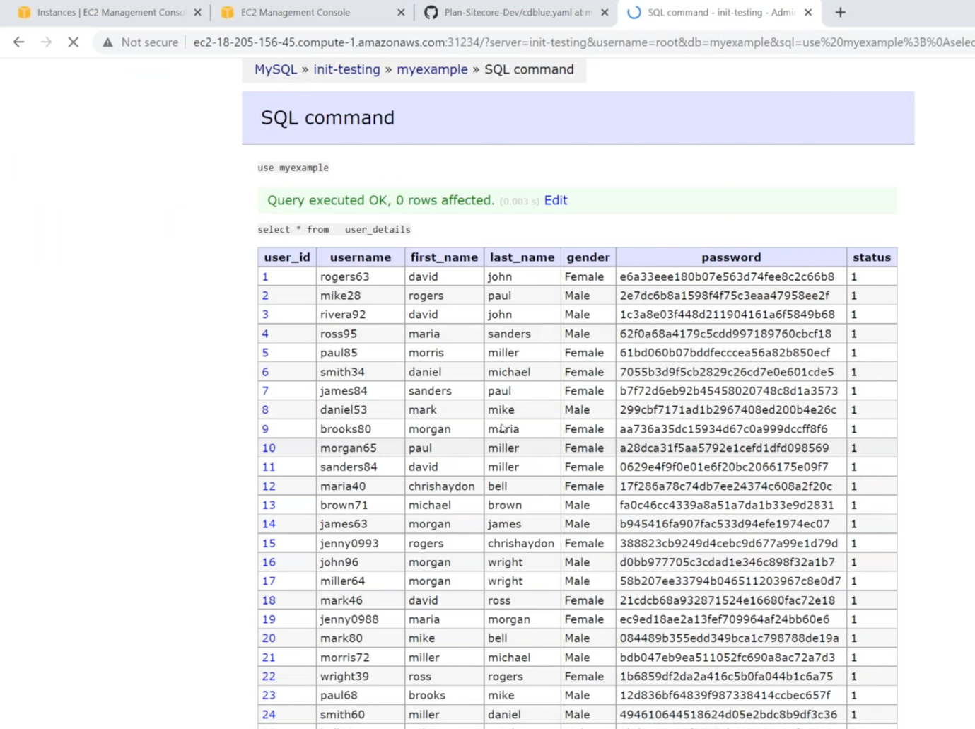

We used inti-container for two purposes. One is two check whether the dependency service is reachable or not. Another one is to download the file before starting the main container.

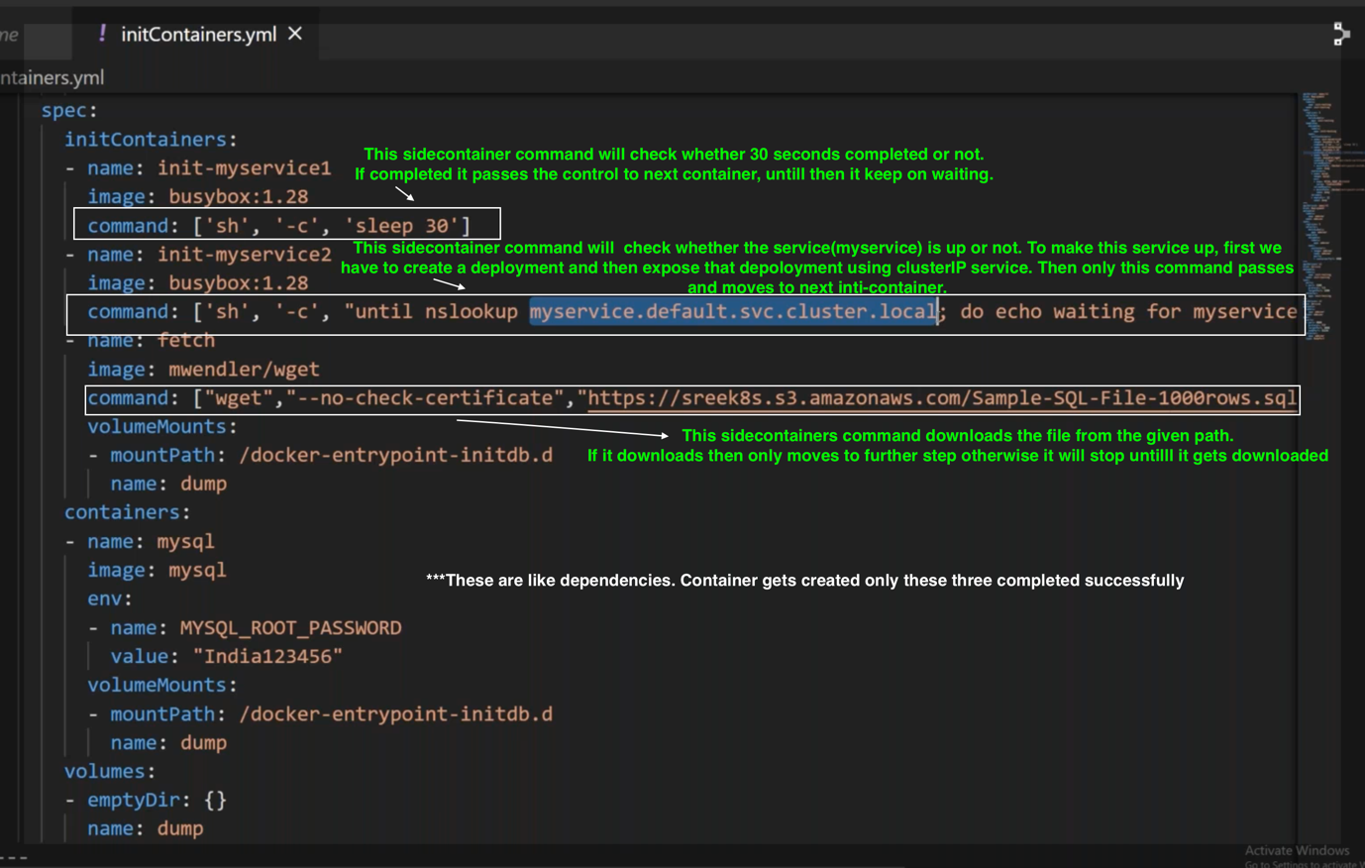

What is sidecar container?

In general, a pod can contains multiple containers. We have a main-container or app-contianer apart from that we can have a side car container for different justification purposes. First type of sidecar container is init-contianer, adapter container and ambassador container. Adapter container runs side by side.

Sidecar container is the additional container that runs along with main-container or app-container. Init-container which will run before the main-container and it will complete before the main-container and it will help us to work with dependency or coping files. Adapter container which runs along with the main-container like handling security, logs routing, proxy etc., . Ambassador container which will be used for proxing database connections like to avoid configuration changes in the main-container. Now we can use the externalName rather than using the Ambassador container.

Adaptive containers

1. It runs along with the main container
2. Best usecases: Routing of logs from the application or istio proxy.

Adaptor-container.yml:

---

apiVersion: v1

kind: Pod

metadata:

name: adapter-container-demo

labels:

env: prod

spec:

initContainers:

- name: init-container

image: alpine/git

command: ["/bin/sh"]

args: ["-c", "git clone https://github.com/mavrick202/dockertest1.git /html"]

volumeMounts:

- name: nginxvol

mountPath: /html/

containers:

- name: adapter-container

image: busybox:1.28

command: ["/bin/sh"]

args: ["-c", "while true; do echo \\<h1\\>$(date)\\</h1\\> >> /html/index.html; sleep 5;done"]

volumeMounts:

- name: nginxvol

mountPath: /html/

- image: nginx:latest

name: main-container

imagePullPolicy: Always

ports:

- containerPort: 80

volumeMounts:

- name: nginxvol

mountPath: /usr/share/nginx/html/

dnsPolicy: Default

volumes:

- name: nginxvol

emptyDir: {}

---

apiVersion: v1

kind: Service

metadata:

labels:

env: prod

name: adapter-container-demo

spec:

ports:

- port: 80

protocol: TCP

targetPort: 80

nodePort: 80

selector:

env: prod

type: NodePort

We creating a yml file and watching the pods to check how it gets create.



In the above file, we are creating a pod and exposing it using service(nodePort). In that pod itself,we have 3 containers. One is init-container that runs before the main-container and second one is adaptor-container which is running along with the third container(main-container).

Once the init-container gets completed then only other two containers begin to run.

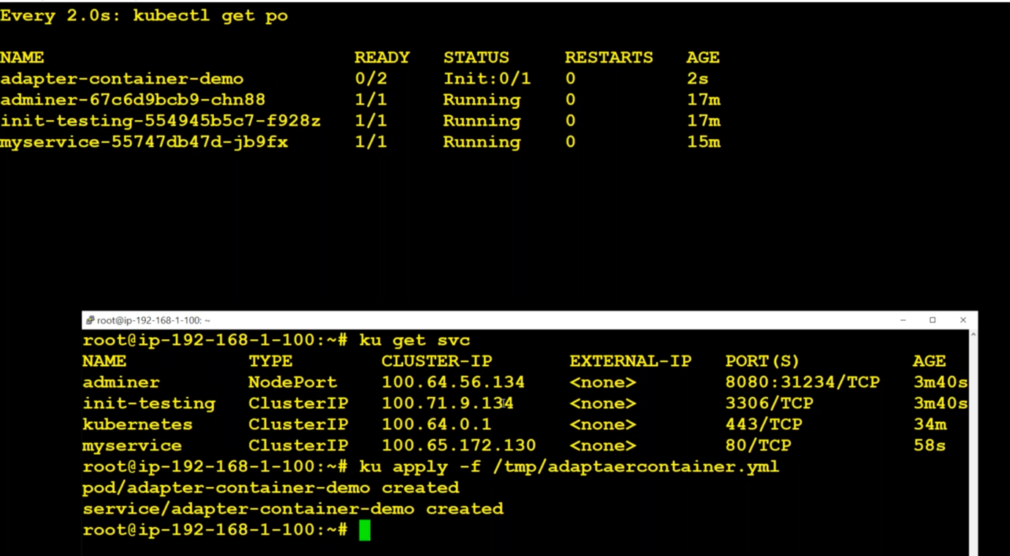

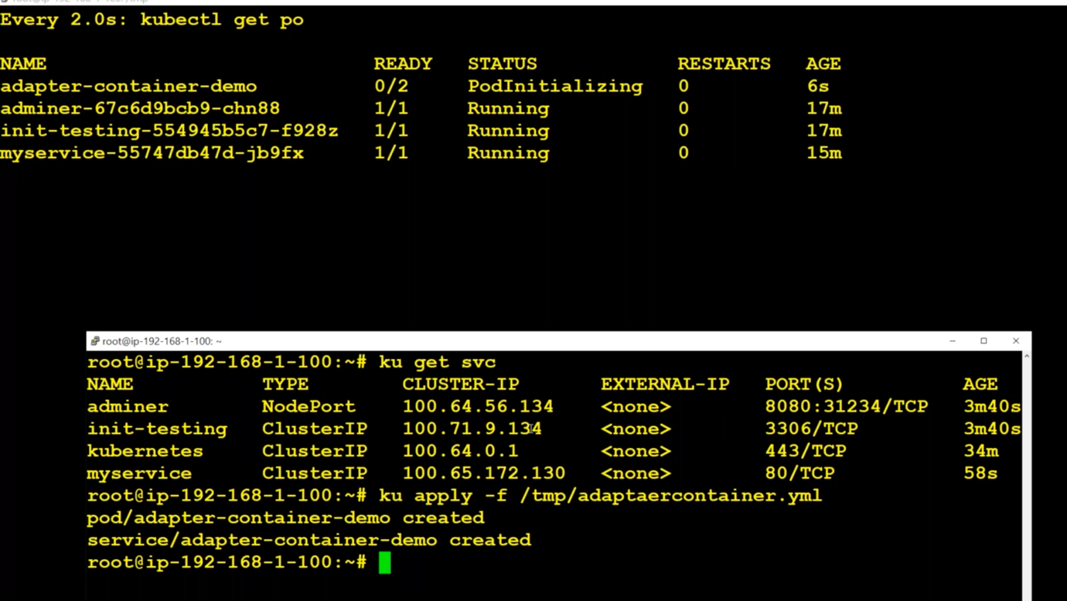

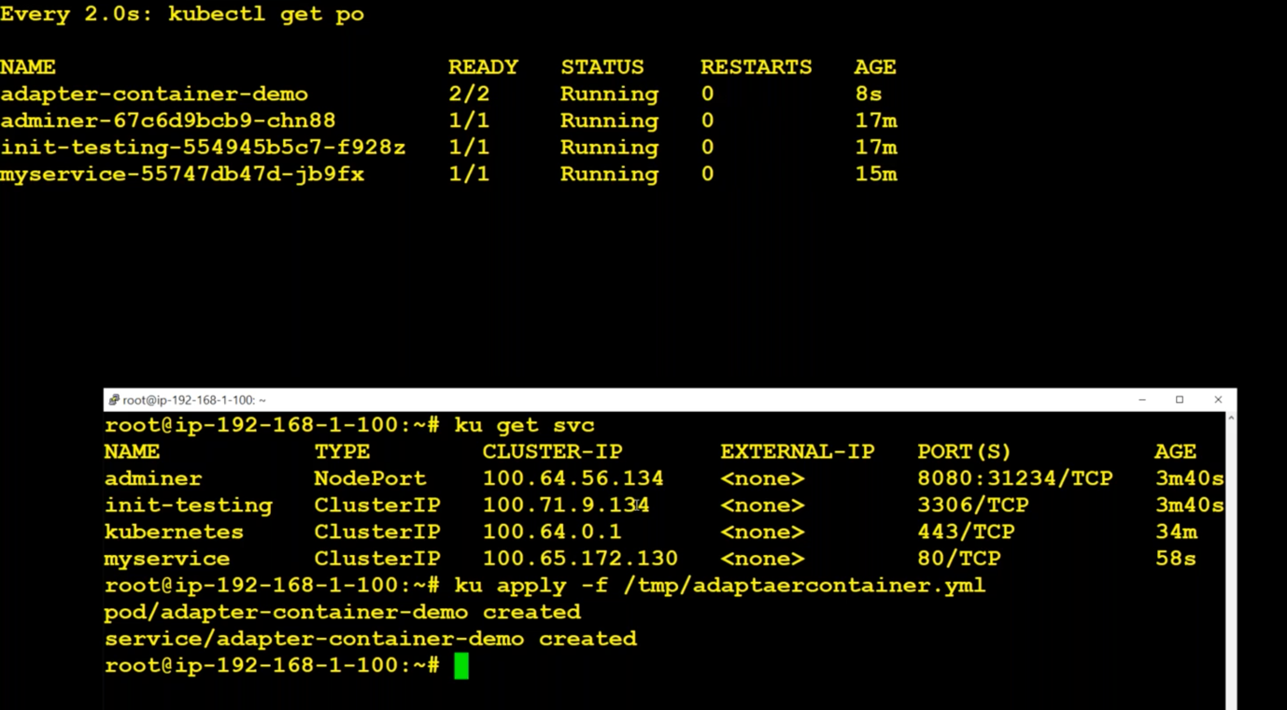

Here we are running two containers inside a pod. Initially, we had three containers, but the the first one was completed as it is init-container and then remaining two contains has started.

To check the three container inside this pod :



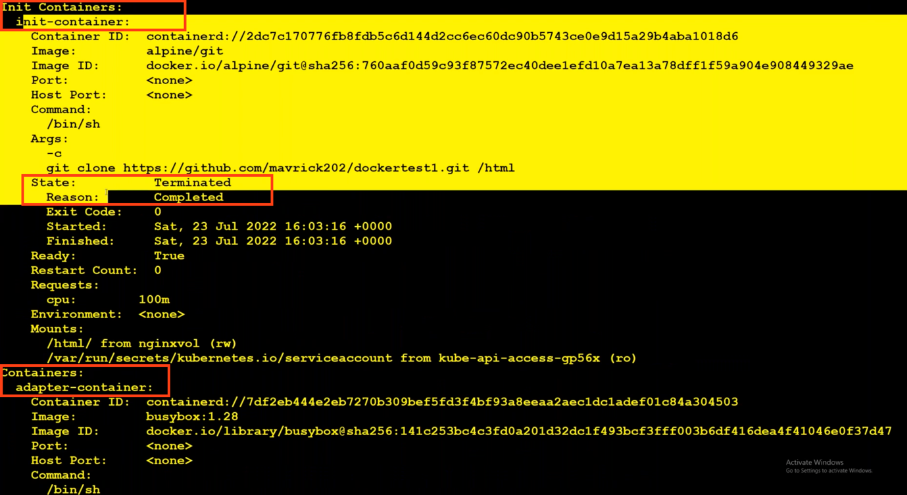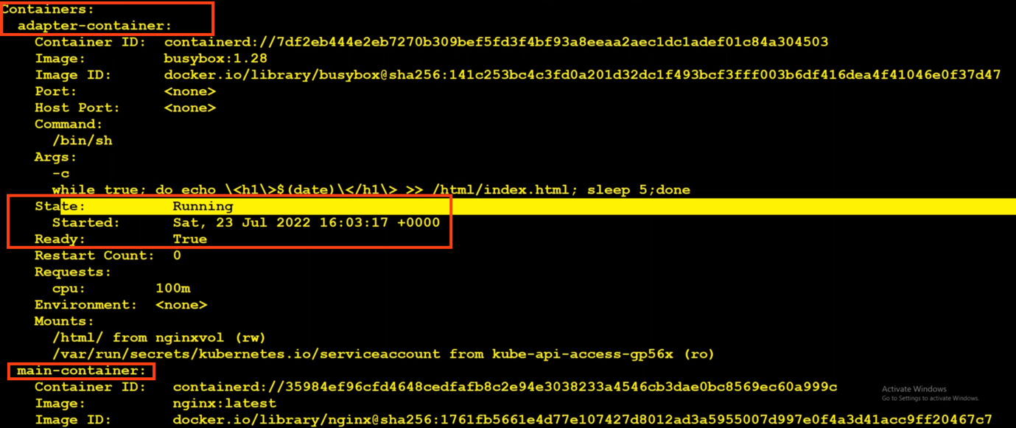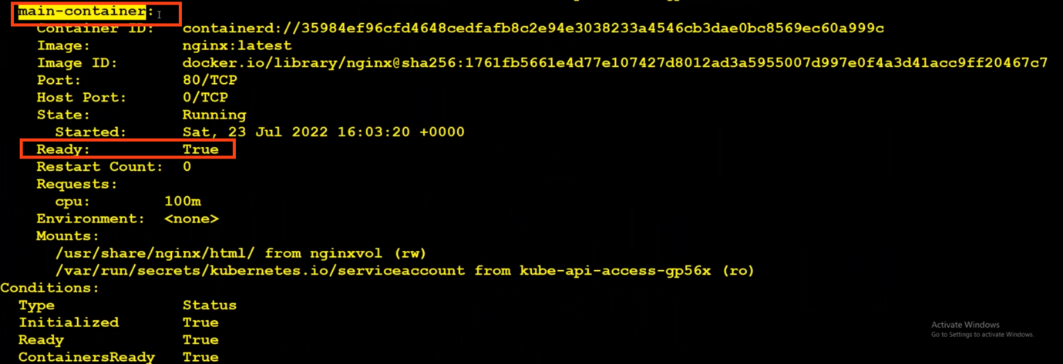

Ambassador containers: It is mostly used for proxying the container. We don’t really need this, because it is replaced by externalName as well as config maps.

2.Probes

How to handle when pods get down all of a sudden or it’s hanging up ?

Create, expose a deployment and try accessing from url :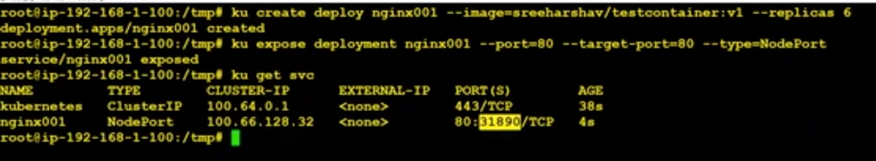

If we try to access this from url on port 31890, immediately service will send the traffic to pods. But my application which is running inside the pod takes 60sec to get up and running. I don’t want Kubernetes to send the traffic to the pod untill its ready.

1. M y application which is running inside the pod takes 60sec to get up and running. I don’t want Kubernetes to send the traffic to the pod untill its ready.

2. Due to some reason if the pod get hanged and unable to serve the traffic, I want to make the POD not ready and reboot the POD after certain period. This reboot is called auto-healing.

We can achieve this by using Readiness Probe, Liveness Probe, startup probe(used for windows machine if it takes more time to start up).

Kubernetes uses readiness probe to know when a container is ready to start accepting traffic.

Readiness probe decides either traffic to be sent to the pod/container or not.

On what basis it decides ?

It checks tcp socket, cmd, httpget

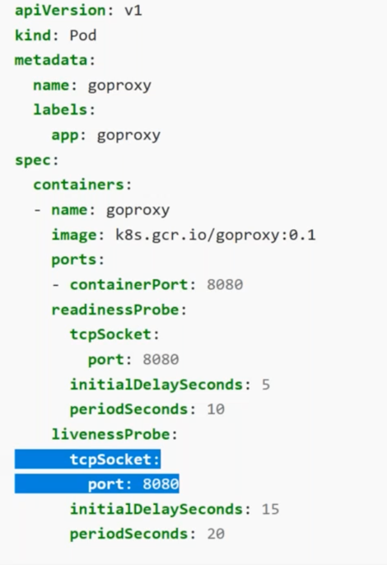

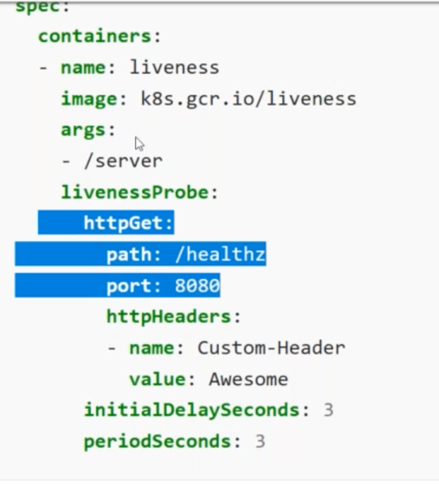

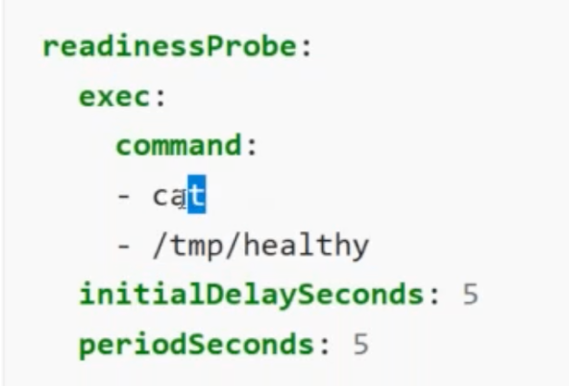

We can use tcp socket and check either the port is working or not.

<https://kubernetes.io/docs/tasks/configure-pod-container/configure-liveness-readiness-startup-probes/>

probe-http-get.yml:

apiVersion: apps/v1

kind: Deployment

metadata:

labels:

app: probetesting

name: probetesting

spec:

replicas: 3

selector:

matchLabels:

app: probetesting

template:

metadata:

labels:

app: probetesting

spec:

containers:

- image: sreeharshav/testcontainer:v1

name: testcontainer

readinessProbe:

initialDelaySeconds: 30

periodSeconds: 5

timeoutSeconds: 10

successThreshold: 1

failureThreshold: 3

httpGet:

path: /

port: 80

---

apiVersion: v1

kind: Service

metadata:

creationTimestamp: null

labels:

app: probetesting

name: probetesting

spec:

ports:

- port: 80

protocol: TCP

targetPort: 80

nodePort: 31111

selector:

app: probetesting

type: NodePort

In the above file, we are creating a deployment and exposing it to the outside using service(NodePort).

Give command echo ‘<filecontent>’ | kubectl apply -f –

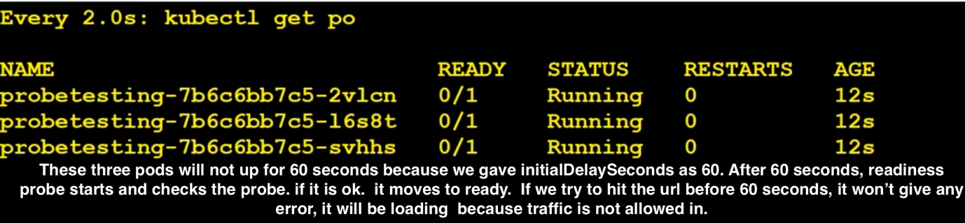

If something happened after running the pods. Something means if pod, gets hanged and due to some reason if application went down. What will happen ?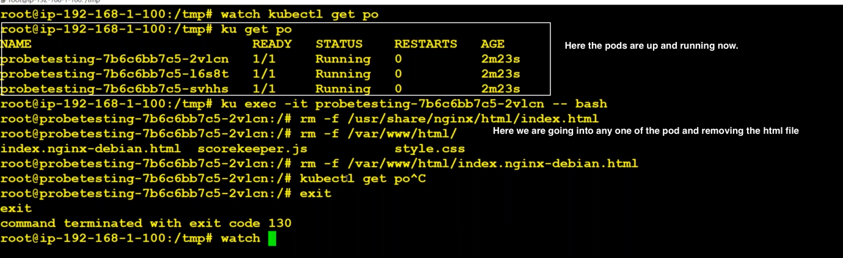

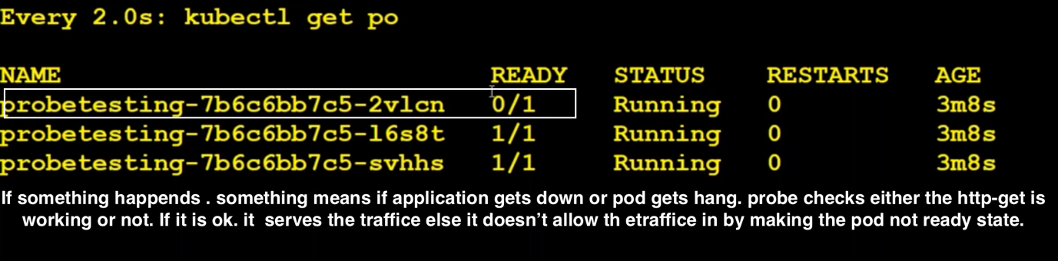

Problem with readiness probe: It won’t auto heal. It means, it any prob fails, traffic will not be sent to that pod. But it won’t make it work well. We have to manually delete the pods. So automatically new pods get created based on the number of replicas we give.

Major difference between readiness and liveness probe is readiness probe cannot restart a container whereas liveness probe restart a container.

Liveness probe:

liveness-probe.yml:

---

apiVersion: apps/v1

kind: Deployment

metadata:

name: nginx-deployment

labels:

app: nginx

spec:

replicas: 3

selector:

matchLabels:

app: nginx

template:

metadata:

labels:

app: nginx

spec:

containers:

- name: nginx

image: sreeharshav/testcontainer:v1

ports:

- containerPort: 80

readinessProbe:

initialDelaySeconds: 45

periodSeconds: 5

timeoutSeconds: 10

successThreshold: 1

failureThreshold: 3

httpGet:

path: /index.nginx-debian.html

port: 80

livenessProbe:

initialDelaySeconds: 60

periodSeconds: 5

timeoutSeconds: 10

successThreshold: 1

failureThreshold: 1

httpGet:

path: /index.nginx-debian.html

port: 80

---

kind: Service

apiVersion: v1

metadata:

name: myservice

labels:

app: nginx

spec:

selector:

app: nginx

type: NodePort

ports:

- name: mynginx

port: 8000

targetPort: 80

run the above file using > echo ‘<file-content>’ | apply -f –

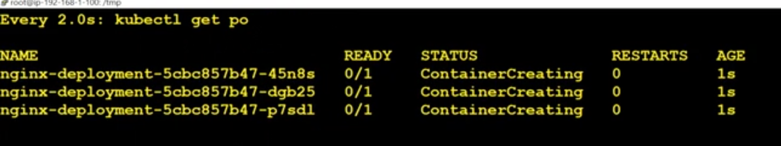

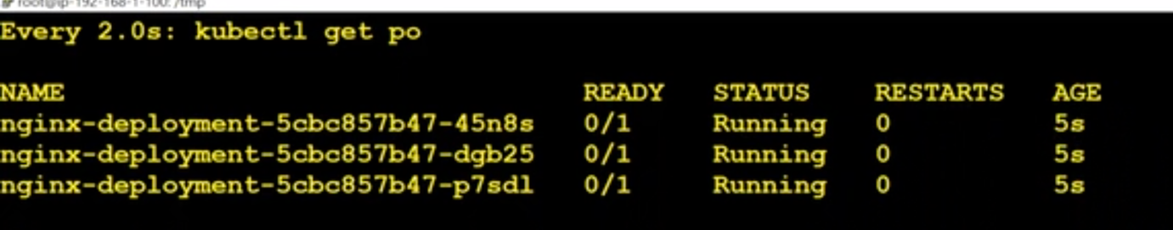

In above picture, pods won’t be up for 45 seconds because, we gave initialDelay as 45 seconds. If traffic is allowed then it moves to 1/1, here traffic is not allowed and it will be checked by the readiness probe.

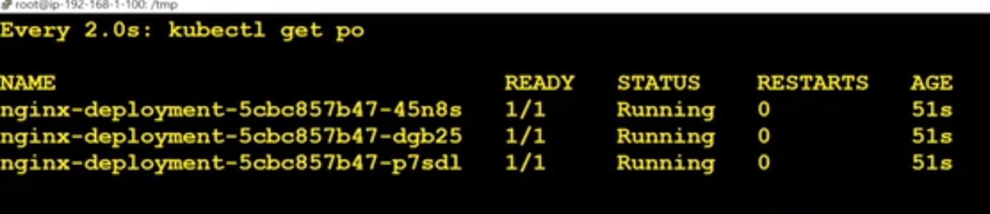

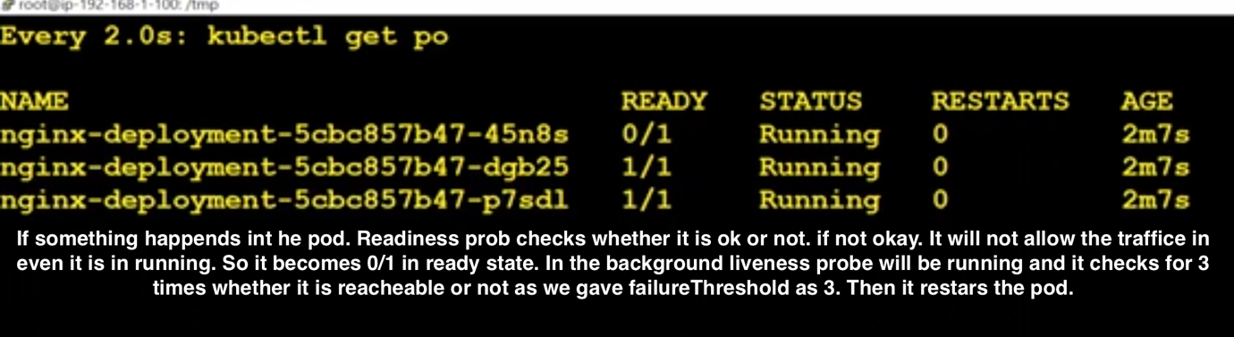

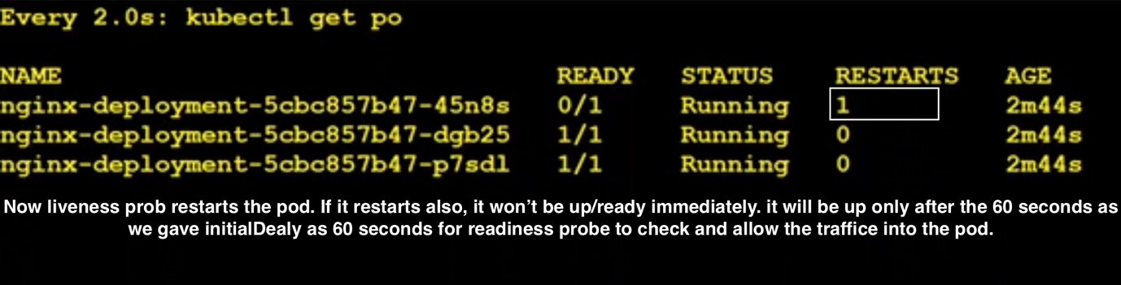

If we want to check who is doing this, we can check by giving

kubectl describe pod <podName>

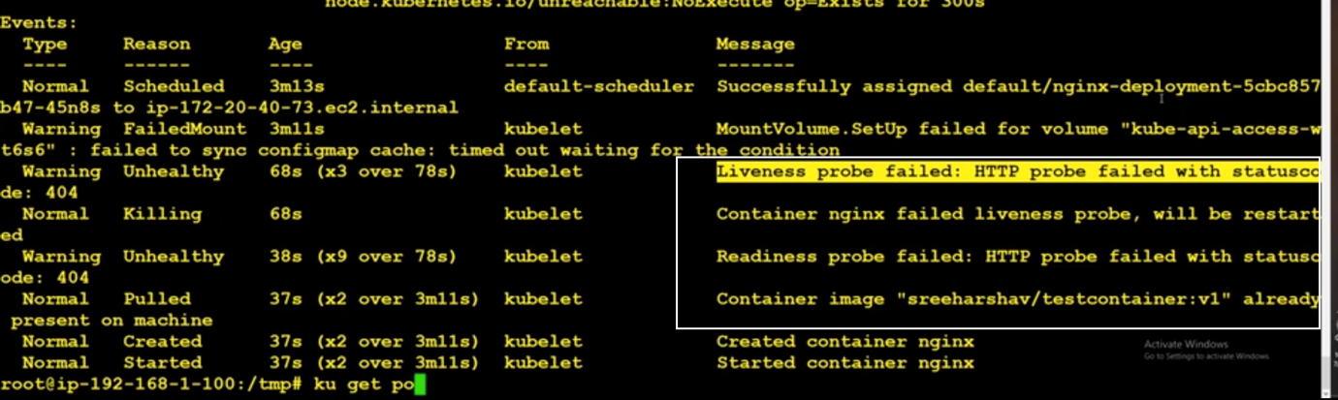

What is readiness and liveness prob? Which one is not necessary?

It not like that it is necessary. Sometimes it depends upon application. But if you ask which one is important. I will say liveness prob is more important because it will reboot the pod.. so auto-healing is enabled. But is better to use both readiness and liveness prob. Liveness prob also works as readiness prob like it will also gives us initialDelay. Readiness prob stops the traffic and it doesn’t reboot the pod where as liveness prob directly reboots the pod and it doesn’t have any thing like stopping the traffic. Startup Prob will be required if we have legacy applications which requires additional startup time. As long as startup prob running, readiness prob and liveness prob will be disabled.

Startup Probe:

3.KubectlDebug

